Price Guide

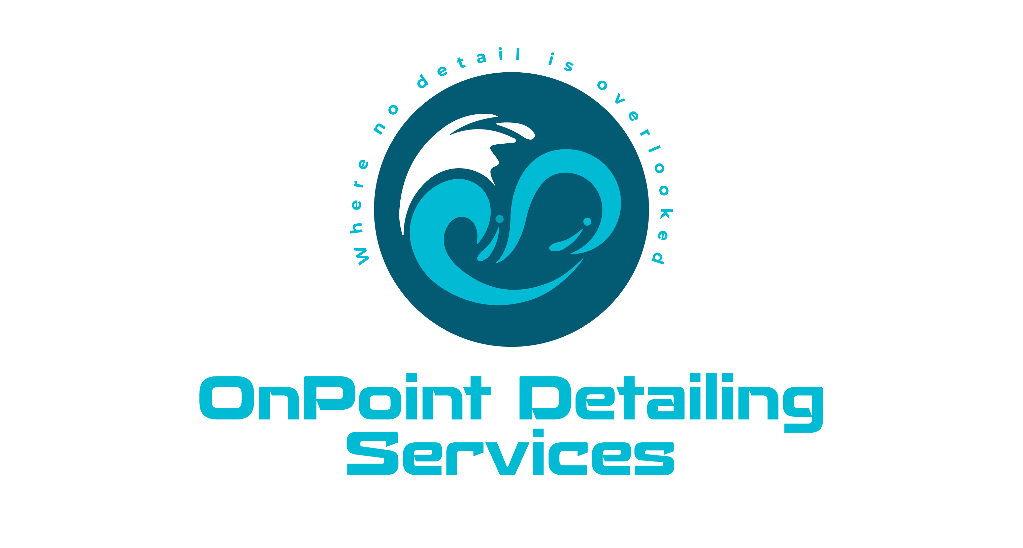

Interior Detail - $150
Package Includes:
- Floor Matts Cleaned
- Door Jambs Cleaned
- Vacuum Clean
- Steam Clean (where needed)
- Interior Wipe Down
- Interior Plastic Protectant
- Glass Cleaned

Interior Detail + Extraction - $180
Package Includes:
- Floor Matts Cleaned
- Door Jambs Cleaned
- Vacuum Clean
- Steam Clean (where needed)
- Interior Wipe Down
- Interior Plastic Protectant
- Glass Cleaned
- Carpet/Upholstery Extraction

* Please Note: Any special circumstances such as the removal of excessive pet hair and significant stains, are all subject to a markup on the price. This markup will be discussed with the client prior to the start of the detail.

To avoid any surprises, please send pictures of your car’s current condition prior to the detail.

